Indian OIL Audit Cost
SL No | Date | Description | Amount
 | 24-01-2025 | Room to Jaipur Station Taxi | 113
 | 24-01-2025 | Water Bottle | 15
 | 23-01-2025 | Jaipur to Agra fort train ticket | 464.25
 | 24-01-2025 | Agra fort to Tundla Taxi (Cash) | 250
 | 24-01-2025 | Dinner + Water (Cash) | 245
 | 24-01-2025 | Tundla to Howrah train ticket | 1869.05
 | 25-01-2025 | Brakefast (Cash) | 100
 | 25-01-2025 | Lunch | 202.53
 | 25-01-2025 | Water (cash) | 40
 | 25-01-2025 | Dinner | 235.41
 | 26-01-2025 | Howrah to Sealdha (Cash) | 200
 | 26-01-2025 | Water | 15
 | 26-01-2025 | Sealdha to Bolpur | 157.25
 | 26-01-2025 | Brakefast (Cash) | 80
 | 26-01-2025 | Lunch + Water (Cash) | 200
 | 26-01-2025 | Dinner | 150
 | 27-01-2025 | Breakfast +water (Cash) | 120
 | 27-01-2025 | Hotel to IOCL | 80
 | 27-01-2025 | Dinner | 150
 | 27-01-2025 | Hotel bill | 2800
 | 28-01-2025 | Bolpur to Howrah | 62.25
 | 28-01-2025 | Brakefast + Water (Cash) | 135
 | 28-01-2025 | Howrah to Esplaned Taxi (cash) | 150
 | 28-01-2025 | Lunch (Cash) | 200
 | 28-01-2025 | Water | 20
 | 28-01-2025 | Esplaned to Haldia | 255
 | 30-01-2025 | Haldia IOCL ( Brakefast + Dinner) | 270
 | 31-01-2025 | Guest House to Bus Stand (Cash) | 50
 | 31-01-2025 | Haldia to Mechada ( Cash) | 160
 | 31-01-2025 | Breakfast+Water (Cash) | 135
 | 31-01-2025 | Mechda to Kharagpur | 15
 | 31-01-2025 | Kharagpur to Hijli (Cash) | 120
 | 31-01-2025 | Water | 20
 | 31-01-2025 | Lunch | 209.19
 | 31-01-2025 | Kharagpur to Cuttuck | 829.05
 | 31-01-2025 | Cuttuck to Bhuvbnneswar (Cash) | 45
 | 31-01-2025 | Dinner + Water (Cash) | 245
 | 31-01-2025 | Hotel | 1100
 | 01-02-2025 | Bhvbnneswar to Paradip | 55
 | 01-02-2025 | Breakfast + Water (Cash) | 120
 | 01-02-2025 | Dinner | 225
 | 01-02-2525 | Water (Cash) | 20
 | 01-02-2025 | Paradip to Babughat | 850
 | 01-02-2025 | Babughat to Sealdha | 150
 | 09-02-2025 | Dum Dum Station to Airport | 188
 | 09-02-2025 | Water (Cash) | 20
 | 09-02-2025 | Air Ticket | 7535
 | 09-02-2025 | Jaipur Airport to Room | 387
 | 09-02-2025 | Lunch | 196
Total = |  |  | 21252.98

24-01-2025
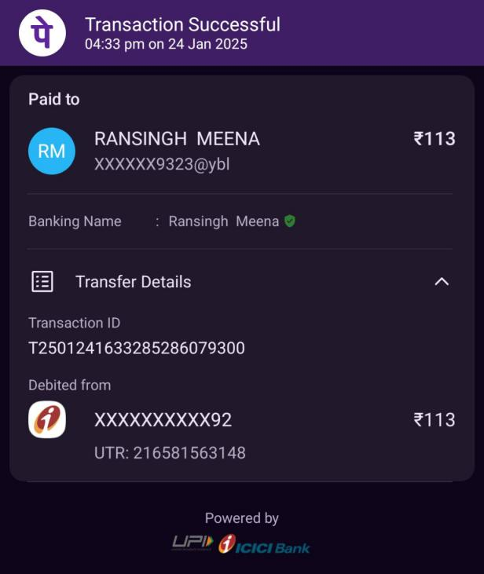 | 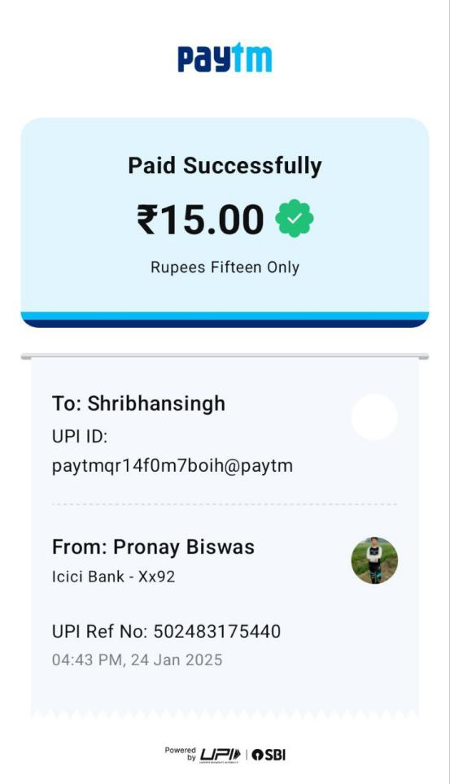
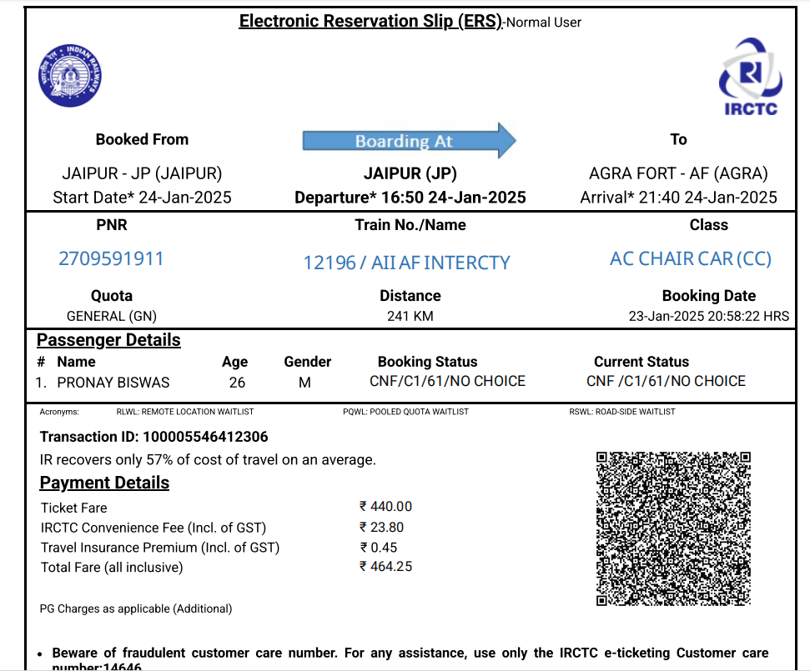
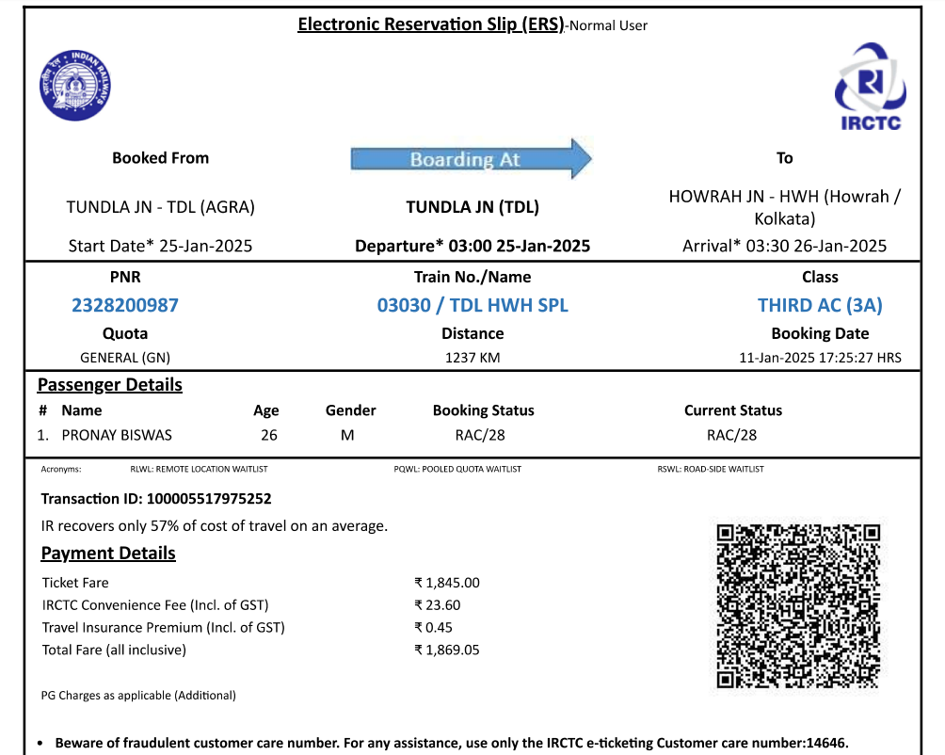
25-01-2025
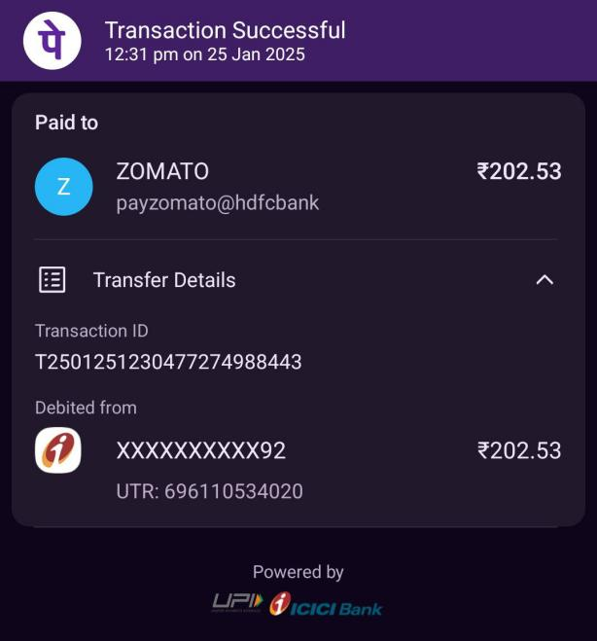 | 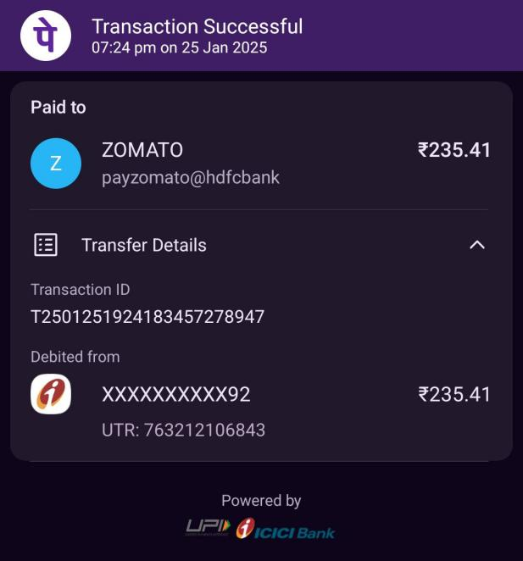
26-01-2025
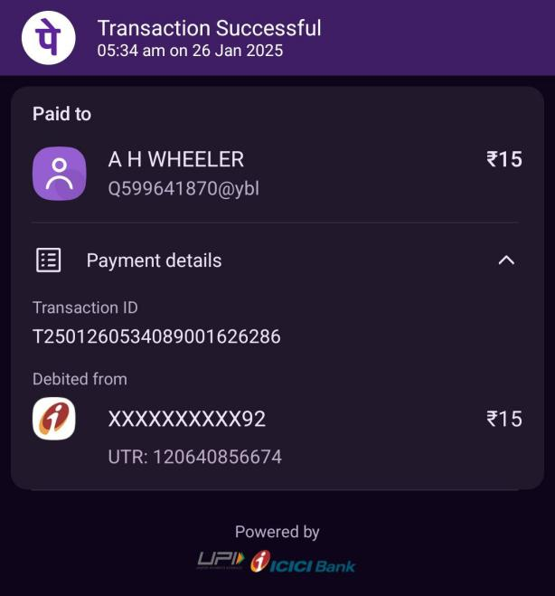
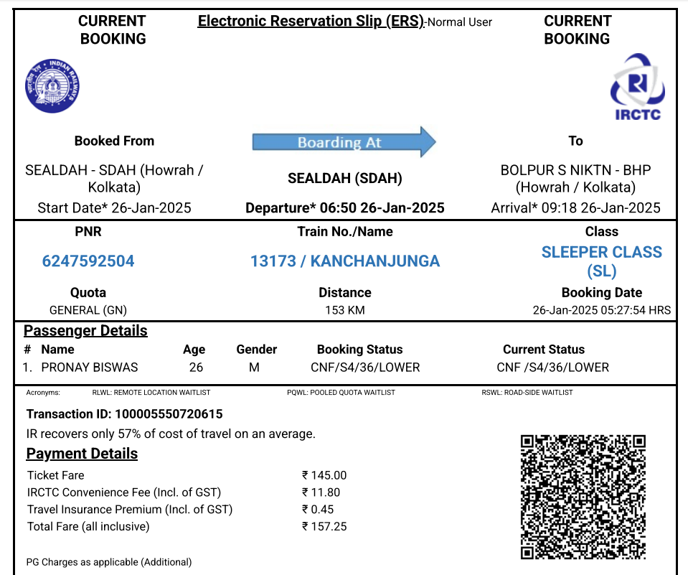
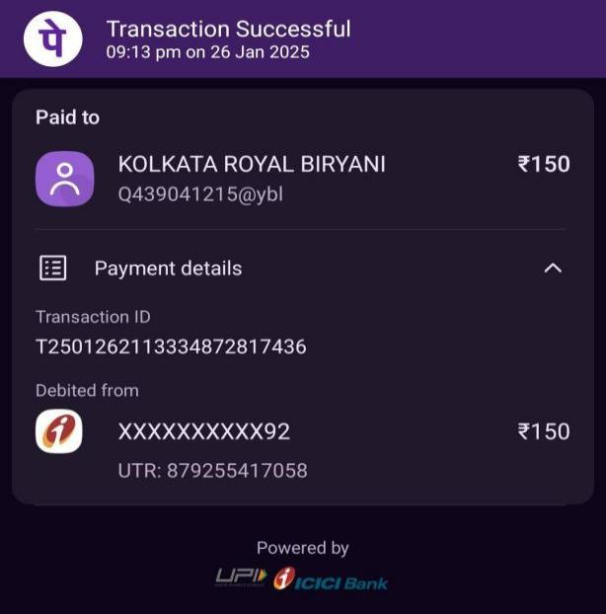
27-01-2025
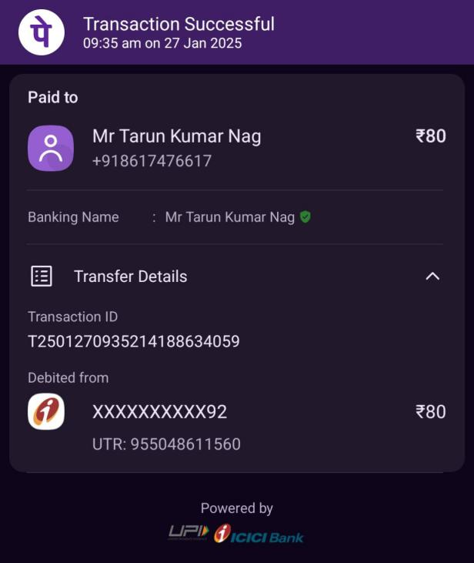 | 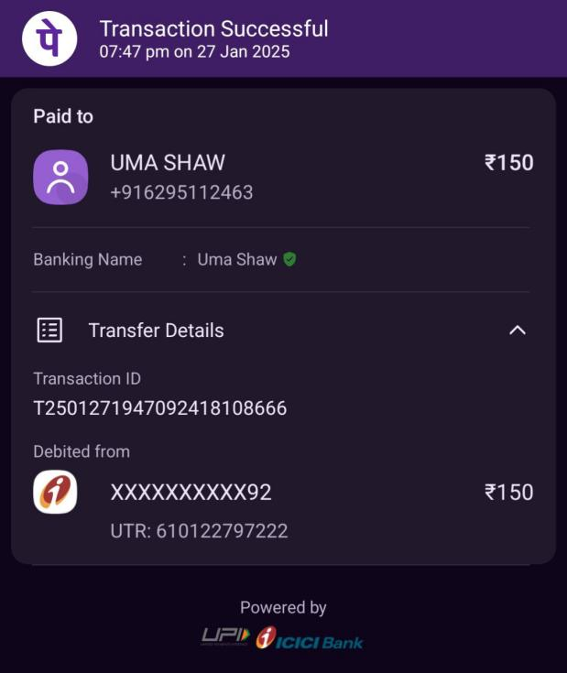
28-01-2025
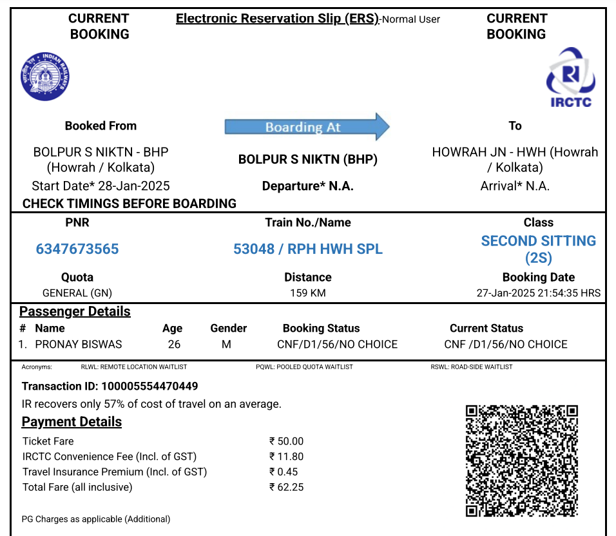
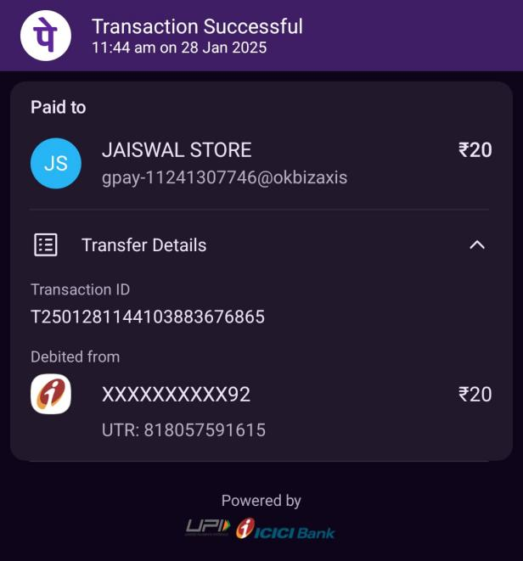
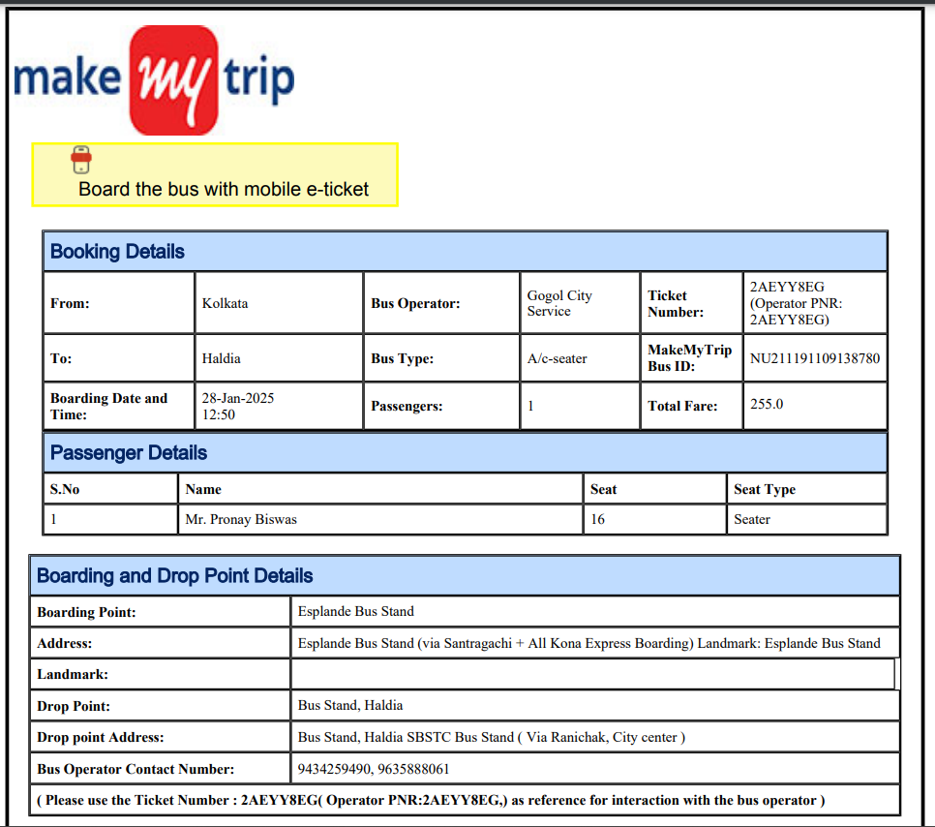
30-01-2025
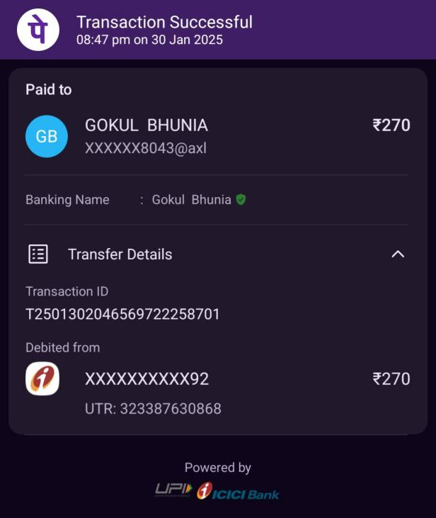
31-01-2025
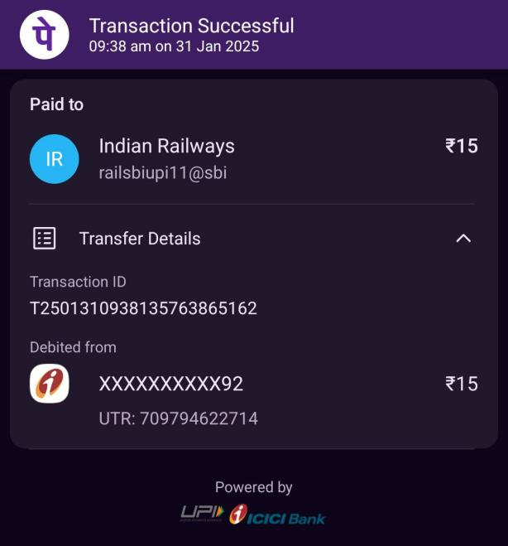 | 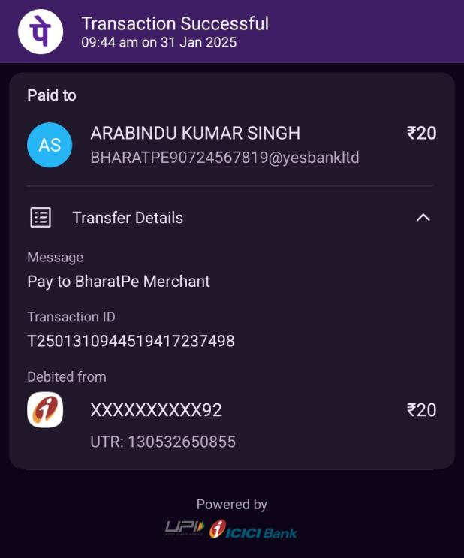
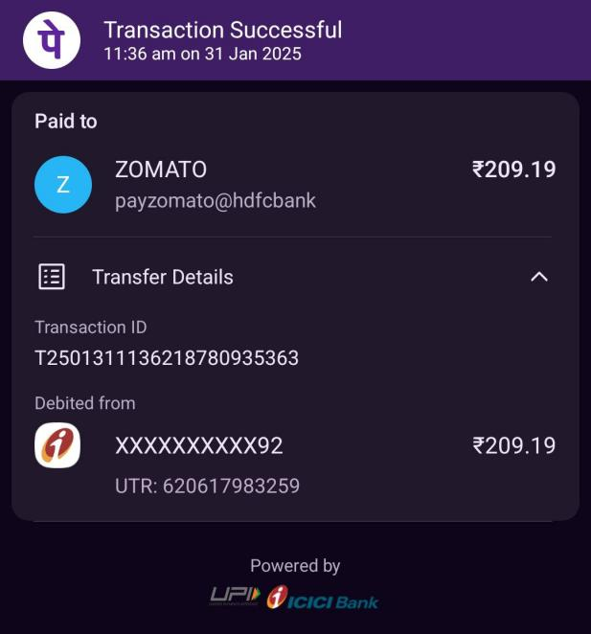
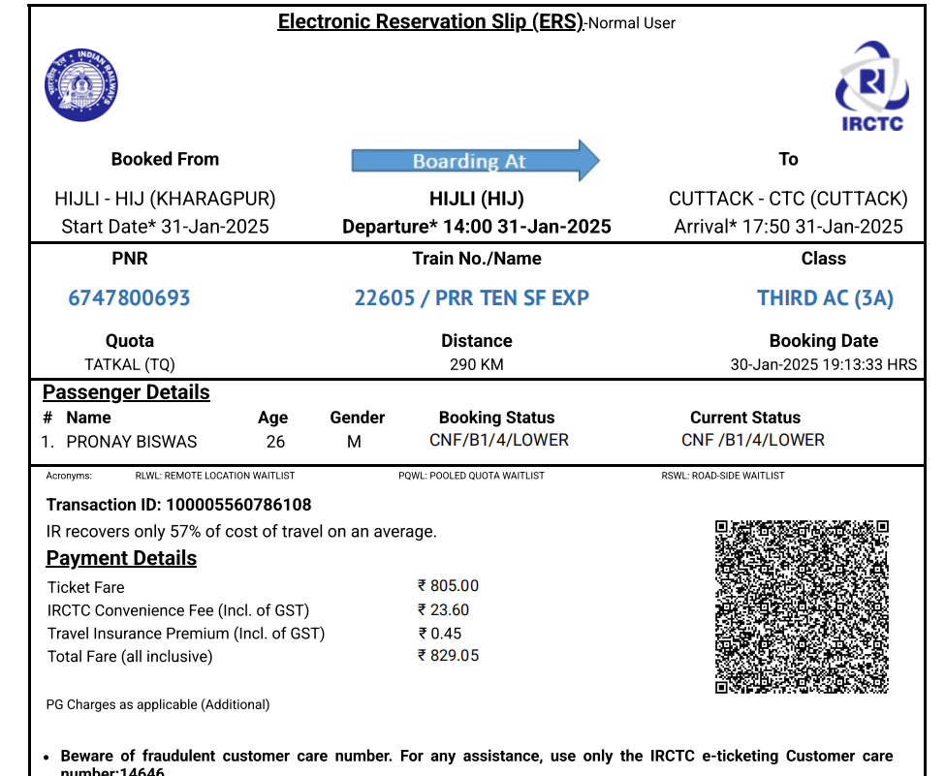
02-02-2025
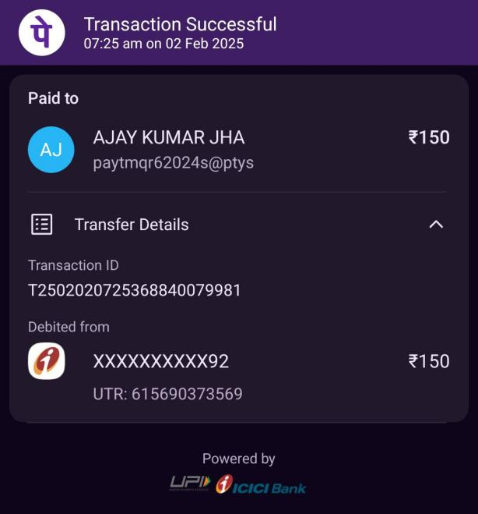
09-02-2025
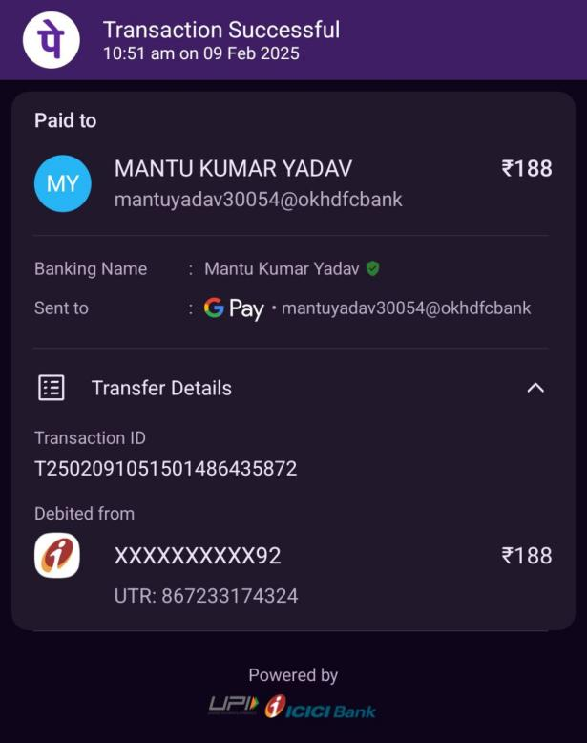 | 